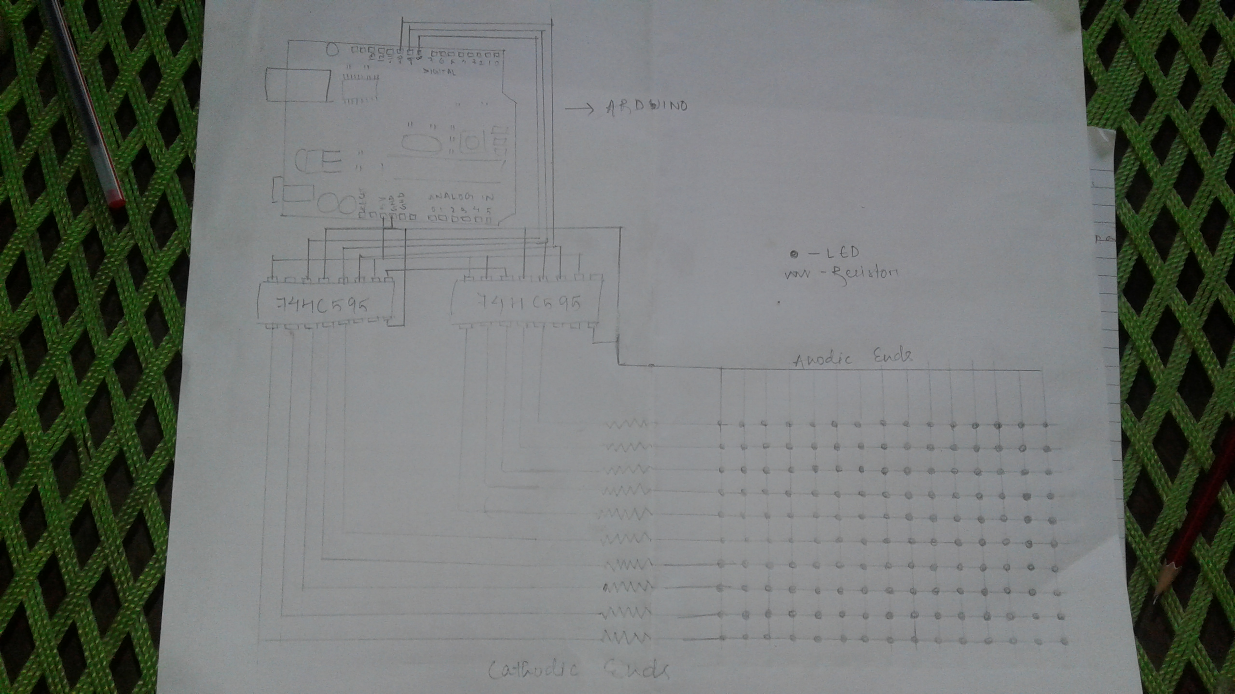

Since i started my work on the provided task on 2nd july
Due to some issues, i could do it till this half way...
*****************
PROJECT
*****************
Here is a diagram for the connection of leds to the arduino.
Here i considered 150 RGB LEDs in a 10*15 manner, where the anodic ends are connected end to end and similarly the cathodic ends are done.(as shown in the diagram)
Since LEDs can not run on heavy input current , i used resistor as the current limiting element.
Here 10 resistors are connected to each cathodic end of 15LEDs.
Value of resistors are considered as per forward current and forward voltage provided.
Here i used two "74HC595" for multiplexing 10 cathodic ends, this helped in incresing digital output pins in the arduino.
By the use of it, 150 leds just require 3arduino pins to run on.Multiplexing is a very efficient technique for controlling many components wired together in a matrix/array.4051). The 74HC595 has 8 outputs labeled Qa-Qh (or Q0-Q7), it cannot read data from these pins, they can only be used as outputs .

The 74HC595 is controlled by three connections to the arduino, they are called the data pin, latch pin, and clock pin.

-first the latch pin is set to ground to disable the outputs, this way the output pins won't change as we are sending in new data to the 74HC595
-next new data is sent to the 74HC595 serially, by pulsing the clock pin and sending each byte of new data out the data pin bit by bit.
-finally, set the latch pin high. This sends new data to all the output pins at once.
Arduino Pin Connections to 74HC595

A0 Clock Pin (pin 11)
A1 Latch Pin (pin 12)
A2 Data Pin (pin 14)
After proper soldering and connections, we need the appropiate coding to light the leds as per our choice.
So overall these are the things i went through within this 1day of time span.
Bt i will try to complete the whole project after college reopens, as i require some guidance and also i dont have the required things with me.

